Relational Databases with MySQL Week 4 Coding Assignment

**Points possible:** 70

|  |  |  |
| --- | --- | --- |
| Category | Criteria | % of Grade |
| Functionality | Does the code work? | 25 |
| Organization | Is the code clean and organized? Proper use of white space, syntax, and consistency are utilized. Names and comments are concise and clear. | 25 |
| Creativity | Student solved the problems presented in the assignment using creativity and out of the box thinking. | 25 |
| Completeness | All requirements of the assignment are complete. | 25 |

**Instructions:** Using a text editor of your choice, write the queries that accomplishes the objectives listed below. Take screenshots of the queries and results and paste them in this document where instructed below. Create a new repository on GitHub for this week’s assignments and push this document, with your Java project code, to the repository. Add the URL for this week’s repository to this document where instructed and submit this document to your instructor when complete.

**Coding Steps:**

Write 5 stored procedures for the employees database.

Write a description of what each stored procedure does and how to use it.

1. This stored procedure can help get the total salary for all current employees combined.

DELIMITER //

DROP PROCEDURE IF EXISTS get_total_salary;

CREATE PROCEDURE get_total_salary()

BEGIN

SET @salary_total = (SELECT SUM(s.salary) from departments d

INNER JOIN dept_emp de ON de.dept_no = d.dept_no

INNER JOIN salaries s ON s.emp_no = de.emp_no);

SET @current_emp_count = (SELECT COUNT(emp_no) FROM dept_emp WHERE to_date > NOW());

SELECT @current_emp_count AS "Current Employees", FORMAT(@salary_total, 'C') AS "Total Salary";

END//

CALL get_total_salary()//

DELIMITER ; //

1. This stored procedure can help publish the lowest salary and the highest salary earned among all salaries of the employees.

DELIMITER //

DROP PROCEDURE IF EXISTS p_salaryrange;

CREATE PROCEDURE p_salaryrange()

BEGIN

SELECT MIN(s.salary) AS 'Lowest Salary', MAX(s.salary) AS 'Highest Salary' from salaries s;

END//

CALL p_salaryrange()//

DELIMITER ; //

1. This stored procedure can take an input parameter to query the employee database and return rows(20) from the table.

DELIMITER //

DROP PROCEDURE IF EXISTS p_employeeList;

CREATE PROCEDURE p_employeeList(

IN firstName VARCHAR(20)

)

BEGIN

SELECT *

FROM employees

WHERE first_name LIKE firstName

LIMIT 20;

END //

CALL p_employeeList('g%')//

DELIMITER ; //

1. This stored procedure can take an input parameter to query the employee database and return result from the table as a parameter which can then be displayed.

DELIMITER // ;

DROP PROCEDURE IF EXISTS p_employees_by_age;

CREATE PROCEDURE p_employees_by_age(IN bornbefore DATE, OUT employees_bornbefore FLOAT)

BEGIN

SELECT COUNT(*) INTO employees_bornbefore

FROM employees

WHERE birth_date < bornbefore;

END //

DELIMITER ; //

CALL p_employees_by_age('1960-01-01', @employees_bornbefore);

Select @employees_bornbefore;

1. This stored procedure uses BEGIN…END and a WHILE … END WHILE. It takes an input parameter to query the employee database and return result into a table that is created to show the results in a nice format.

DELIMITER ;

DROP TABLE IF EXISTS interim;

CREATE TABLE interim (

employee_id INT (11),

employee_fname varchar (45)

);

DELIMITER // ;

DROP PROCEDURE IF EXISTS p_show_ten_employees;

CREATE PROCEDURE p_show_ten_employees(IN input_emp_no INT)

BEGIN

DECLARE A INT;

DECLARE input_emp_fname CHAR(45);

DECLARE input_emp_lname CHAR(20);

SET A = 1;

WHILE A <=10 DO

SELECT CONCAT(first_name, " ", last_name)INTO input_emp_fname

FROM employees

WHERE emp_no = input_emp_no;

SET A = A + 1;

INSERT INTO interim VALUES (input_emp_no, input_emp_fname);

SET input_emp_no = (input_emp_no + 1);

END WHILE;

SELECT employee_id AS "Employee ID", employee_fname AS "Employee Name" FROM interim;

END//

DELIMITER ; //

CALL p_show_ten_employees(10050);

Procedures should use constructs you learned about from your research assignment and be more than just queries.

In Closing: Dropping all created stored procedures that were created for this assignment:

DROP PROCEDURE IF EXISTS get_total_salary;

DROP PROCEDURE IF EXISTS p_salaryrange;

DROP PROCEDURE IF EXISTS p_employeeList;

DROP PROCEDURE IF EXISTS p_employees_by_age;

DROP PROCEDURE IF EXISTS p_show_ten_employees;

DROP TABLE IF EXISTS interim;

**Screenshots:**

1. This stored procedure can help get the total salary for all current employees combined.

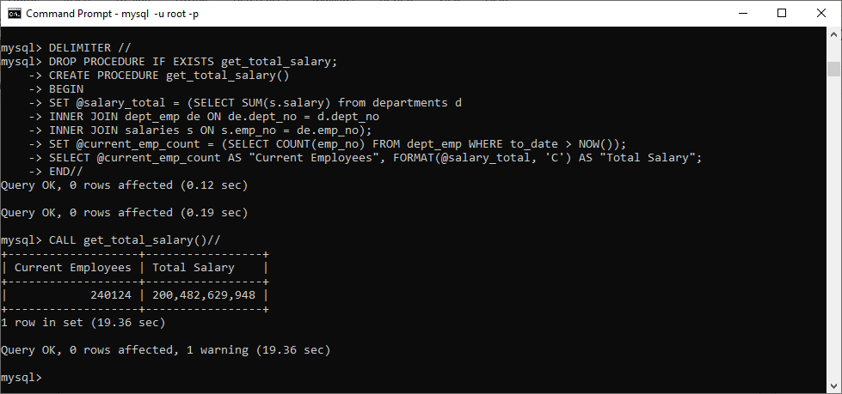

1. This stored procedure can help publish the lowest salary and the highest salary earned among all salaries of the employees.

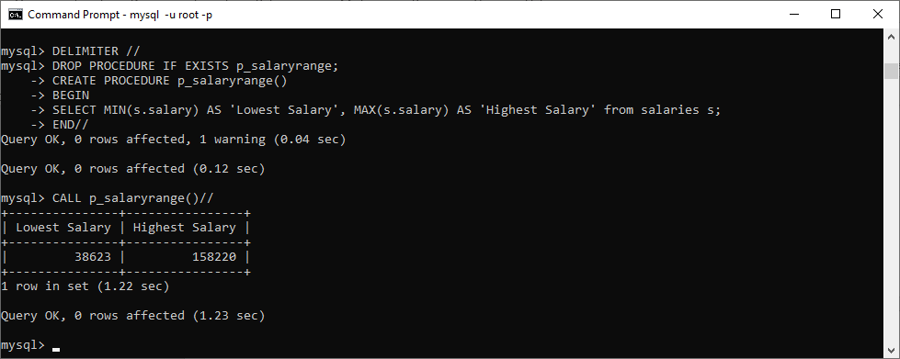

1. This stored procedure can take an input parameter to query the employee database and return rows (20) from the table.

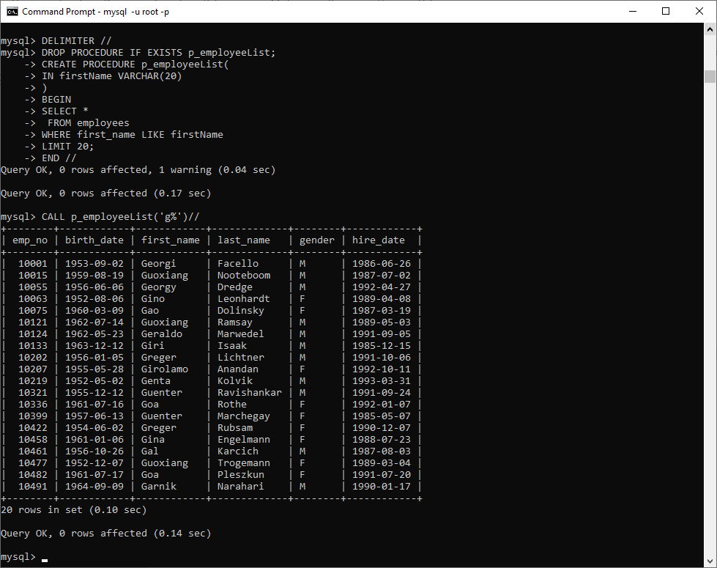

1. This stored procedure can take an input parameter to query the employee database and return result from the table as a parameter which can then be displayed.

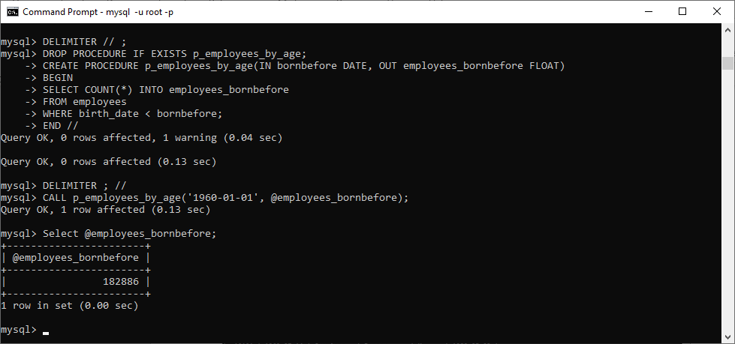

1. This stored procedure uses BEGIN…END and a WHILE … END WHILE. It takes an input parameter to query the employee database and return result into a table that is created to show the results in a nice format.

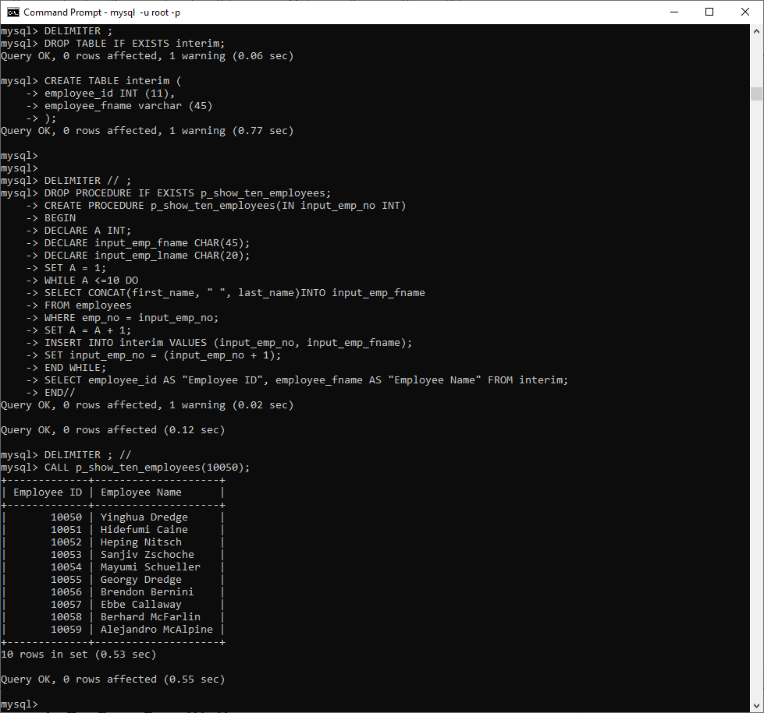

**URL to GitHub Repository:**

<https://github.com/srikripa/MSQL-Repos-W4.git>